EXPERIMENT 1
IMPLEMENTATION OF CAESAR CIPHER (PYTHON)
AIM
To implement the Caesar Cipher substitution technique using Python.
ALGORITHM
- Read the plaintext from the user.
- Read the key (shift value) from the user.
- For each character in the plaintext: if it is an uppercase letter, shift it by the key within A-Z; if it is a lowercase letter, shift it by the key within a-z; leave non-alphabetic characters unchanged.
- Display the encrypted (cipher) text.
- Decrypt the cipher text by shifting each character backward using the same key.
- Display the decrypted text.
CODE
def encrypt(text, key):
cipher = ""
for ch in text:
if ch.isupper():
cipher += chr((ord(ch) - ord('A') + key) % 26 + ord('A'))
elif ch.islower():
cipher += chr((ord(ch) - ord('a') + key) % 26 + ord('a'))
else:
cipher += ch
return cipher

def decrypt(cipher, key):
text = ""
for ch in cipher:
if ch.isupper():
text += chr((ord(ch) - ord('A') - key) % 26 + ord('A'))
elif ch.islower():
text += chr((ord(ch) - ord('a') - key) % 26 + ord('a'))
else:
text += ch
return text

plain = input("Enter the plain text: ")
key = int(input("Enter the key value: "))
cipher = encrypt(plain, key)
print("Encrypted Text:", cipher)
decrypted = decrypt(cipher, key)
print("Decrypted Text:", decrypted)
OUTPUT
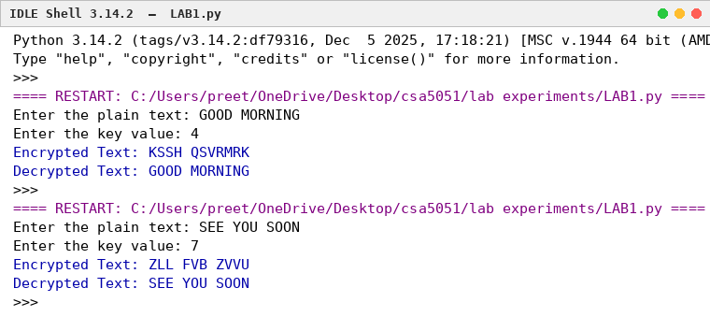
RESULT
Thus, the Caesar Cipher substitution technique was implemented successfully using Python.

EXPERIMENT 2
MONOALPHABETIC SUBSTITUTION CIPHER (PYTHON)
AIM
To implement the Monoalphabetic Substitution Cipher using Python.
ALGORITHM
- Read the plaintext from the user.
- Define a substitution key containing all 26 unique alphabet letters.
- Replace each plaintext letter with its corresponding letter from the substitution key.
- Display the encrypted (cipher) text.
- For decryption, replace each cipher letter with its corresponding original alphabet letter.
- Display the decrypted text.
CODE
import string
alphabet = string.ascii_uppercase
key = "QWERTYUIOPASDFGHJKLZXCVBNM"
plain = input("Enter the plain text: ").upper()

# Encryption
cipher = ""
for ch in plain:
if ch.isalpha():
index = alphabet.index(ch)
cipher += key[index]
else:
cipher += ch
print("Encrypted Text:", cipher)

# Decryption
decrypted = ""
for ch in cipher:
if ch.isalpha():
index = key.index(ch)
decrypted += alphabet[index]
else:
decrypted += ch
print("Decrypted Text:", decrypted)
OUTPUT
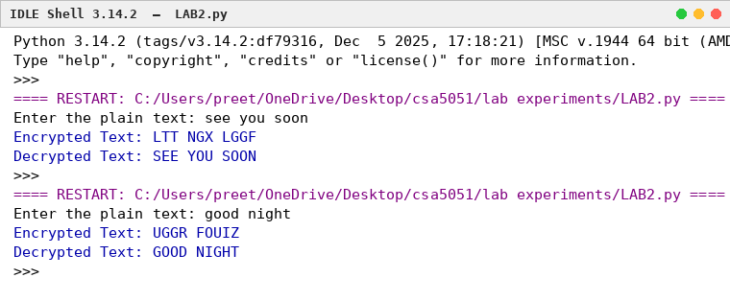
RESULT
Thus, the Monoalphabetic Substitution Cipher was implemented successfully using Python.

EXPERIMENT 3
POLYALPHABETIC CIPHER (VIGENÈRE CIPHER) – PYTHON
AIM
To implement the Vigenère (Polyalphabetic) Cipher substitution technique using Python.
ALGORITHM
- Read the plaintext from the user.
- Read the keyword from the user.
- Repeat the keyword until its length matches the plaintext.
- Encrypt each character by adding the positions of the plaintext character and the corresponding key character modulo 26.
- Display the encrypted (cipher) text.
- Decrypt the cipher text by subtracting the key character value from the cipher character modulo 26.
- Display the decrypted text.
CODE
def generate_key(text, key):
key = key.upper()
text = text.upper()
new_key = ""
j = 0
for ch in text:
if ch.isalpha():
new_key += key[j % len(key)]
j += 1
else:
new_key += ch
return new_key

def encrypt(text, key):
text = text.upper()
key = generate_key(text, key)
cipher = ""
for i in range(len(text)):
if text[i].isalpha():
x = (ord(text[i]) - ord('A') + ord(key[i]) - ord('A')) % 26
cipher += chr(x + ord('A'))
else:
cipher += text[i]
return cipher

def decrypt(cipher, key):
cipher = cipher.upper()
key = generate_key(cipher, key)
plain = ""
for i in range(len(cipher)):
if cipher[i].isalpha():
x = (ord(cipher[i]) - ord(key[i])) % 26
plain += chr(x + ord('A'))
else:
plain += cipher[i]
return plain

plaintext = input("Enter Plain Text: ")
key = input("Enter Key: ")

cipher = encrypt(plaintext, key)
print("Encrypted Text:", cipher)

plain = decrypt(cipher, key)
print("Decrypted Text:", plain)
OUTPUT
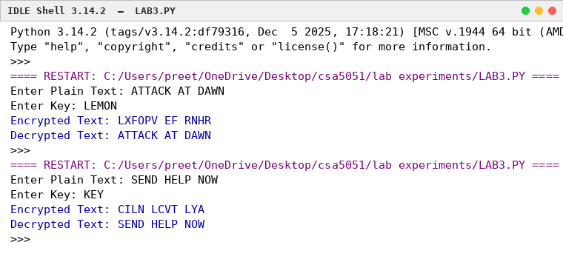
RESULT
Thus, the Vigenère (Polyalphabetic) Cipher substitution technique was implemented successfully using Python.

EXPERIMENT 4
HILL CIPHER
AIM
To implement the Hill Cipher substitution technique using Python.
ALGORITHM
- Read the plaintext from the user.
- Read the 3×3 key matrix.
- Convert the plaintext into numerical values (A=0, B=1, ..., Z=25).
- Multiply the plaintext vector with the key matrix modulo 26.
- Convert the result back to characters to obtain the cipher text.
- Display the encrypted text.
CODE
key = [
[6, 24, 1],
[13, 16, 10],
[20, 17, 15]
]

text = input("Enter Plain Text (3 letters): ").upper()
while len(text) < 3:
text += "X"
text = text[:3]

P = [ord(ch) - 65 for ch in text]
C = []

for i in range(3):
total = 0
for j in range(3):
total += key[i][j] * P[j]
C.append(total % 26)

cipher = ""
for num in C:
cipher += chr(num + 65)

print("Encrypted Text:", cipher)
OUTPUT
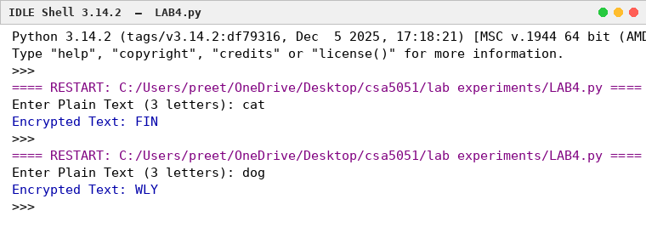
RESULT
Thus the Hill Cipher substitution technique was implemented successfully using Python.

EXPERIMENT 5
PLAYFAIR CIPHER
AIM
To implement the Playfair Cipher substitution technique using Python.
ALGORITHM
- Read the plaintext and keyword.
- Construct the 5×5 key matrix.
- Split the plaintext into pairs.
- Apply Playfair encryption rules.
- Display the encrypted text.
CODE
def generate_key_table(key):
key = key.upper().replace("J", "I")
table = []
for c in key:
if c not in table and c.isalpha():
table.append(c)
for c in "ABCDEFGHIKLMNOPQRSTUVWXYZ":
if c not in table:
table.append(c)
return [table[i:i+5] for i in range(0, 25, 5)]

def find(table, ch):
for i in range(5):
for j in range(5):
if table[i][j] == ch:
return i, j

def encrypt(text, table):
text = text.upper().replace("J", "I")
text = "".join(c for c in text if c.isalpha())
pairs = []
i = 0
while i < len(text):
a = text[i]
if i + 1 < len(text):
b = text[i + 1]
if a == b:
pairs.append((a, "X"))
i += 1
else:
pairs.append((a, b))
i += 2
else:
pairs.append((a, "X"))
i += 1

cipher = ""
for a, b in pairs:
r1, c1 = find(table, a)
r2, c2 = find(table, b)
if r1 == r2:
cipher += table[r1][(c1 + 1) % 5]
cipher += table[r2][(c2 + 1) % 5]
elif c1 == c2:
cipher += table[(r1 + 1) % 5][c1]
cipher += table[(r2 + 1) % 5][c2]
else:
cipher += table[r1][c2]
cipher += table[r2][c1]
return cipher

key = input("Enter Key: ")
plain = input("Enter Plain Text: ")

table = generate_key_table(key)

print("Encrypted Text:", encrypt(plain, table))
OUTPUT
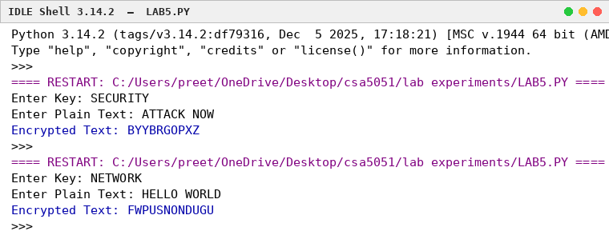
RESULT
Thus the Playfair Cipher substitution technique was implemented successfully using Python.

EXPERIMENT 6
RAIL FENCE CIPHER
AIM
To implement the Rail Fence transposition technique using Python.
ALGORITHM
- Read the plaintext.
- Arrange the characters in zig-zag order.
- Read the rows sequentially to obtain the cipher text.
- Display the encrypted text.
CODE
def encrypt(text):
rail1 = ""
rail2 = ""
for i in range(len(text)):
if i % 2 == 0:
rail1 += text[i]
else:
rail2 += text[i]
return rail1 + rail2

plain = input("Enter Plain Text: ")
cipher = encrypt(plain)
print("Encrypted Text:", cipher)
OUTPUT
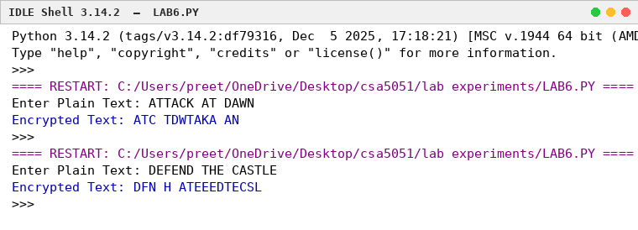
RESULT
Thus the Rail Fence transposition technique was implemented successfully using Python.

EXPERIMENT 7
COLUMNAR TRANSPOSITION CIPHER
AIM
To implement the Columnar Transposition Cipher using Python.
ALGORITHM
- Read the plaintext and keyword.
- Arrange the plaintext row-wise in a matrix.
- Number the columns according to the alphabetical order of the keyword.
- Read the columns in sorted-key order.
- Display the encrypted text.
CODE
import math

text = input("Enter Plain Text: ").replace(" ", "").upper()
key = input("Enter Key: ").upper()

col = len(key)
row = math.ceil(len(text) / col)
fill = row * col - len(text)
text += "X" * fill

matrix = []
k = 0
for i in range(row):
matrix.append(list(text[k:k + col]))
k += col

order = sorted(list(enumerate(key)), key=lambda x: x[1])

cipher = ""
for index, _ in order:
for r in matrix:
cipher += r[index]

print("Encrypted Text:", cipher)
OUTPUT
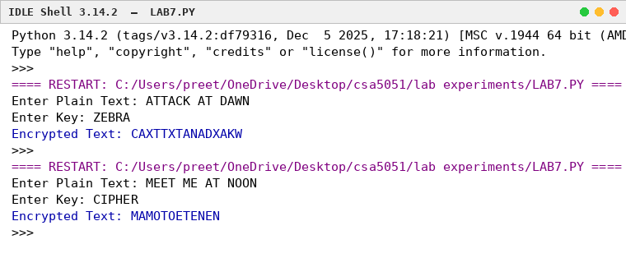
RESULT
Thus the Columnar Transposition Cipher was implemented successfully using Python.

